**IMPLEMENTATION OF AUTOMATED LIBRARY MANAGEMENT SYSTEM WITH AI INTEGRATION**

A Capstone Project Proposal Presented to

the Faculty of College of Computer Studies Department

**BENEDICTO COLLEGE - MANDAUE CAMPUS**

A.S. Fortuna St., Mandaue City, Cebu

In Partial Fulfillment with the Requirements for the Conferment Degree of

**Bachelor of Science in Information Technology**

JON MARNEIL F. CABAHUG

ARJANE R. CABATINGAN

JEVY M. CASTRO

RENFRED D. CORNEJO

NATHANIEL P. INOCANDO

ALESON C. IRAG

MAY 2025

**APPROVAL SHEET**

The Capstone Project entitled “**IMPLEMENTATION OF AUTOMATED LIBRARY MANAGEMENT SYSTEM WITH AI INTEGRATION**” prepared and presented by JON MARNEIL F. CABAHUG, ARJANE R. CABATINGAN, JEVY M. CASTRO, RENFRED D. CORNEJO, NATHANIEL P. INOCANDO, ALESON C. IRAG, in partial fulfillment of the requirements for subject ____________ will be examined and recommended for acceptance and approval for **Oral Examination.**

**CAPSTONE PROJECT ADVISORY COMMITTEE**

**GENE PAUL R. CUEVA, MBA, MSIT**

Chairman

**LENY B. YAMILO, LPT, DPA (diss)** **JOSE MARCELITO D. BRIGOLI**

Adviser Member

Approved by the Committee on Project Presentation with a grade of ____________

**GENE PAUL R. CUEVA, MBA, MSIT**

Chairman

**LENY B. YAMILO, LPT, DPA (diss)** **JOSE MARCELITO D. BRIGOLI**

Adviser Member

**ACCEPTED AND APPROVED** in partial fulfillment of the degree **BACHELOR OF SCIENCE IN INFORMATION TECHNOLOGY**

Date of Project Presentation:

**PROF. GENE PAUL R. CUEVA**

Dean, College of Computer Studies

**ABSTRACT**

|  |  |
| --- | --- |
| TITLE | IMPLEMENTATION OF AUTOMATED LIBRARY MANAGEMENT SYSTEM WITH AI INTEGRATION |
| RESEARCHERS | JON MARNEIL F. CABAHUG  ARJANE R. CABATINGAN  JEVY M. CASTRO  RENFRED D. CORNEJO  NATHANIEL P. INOCANDO  ALESON C. IRAG |
| DEGREE | BACHELOR OF SCIENCE IN INFORMATION TECHNOLOGY |
| ADVISER | PROF. LENY B. YAMILO, LPT,DPA **(diss)** |
| INSTITUTION AND ADDRESS | BENEDICTO COLLEGE, A.S. FORTUNA ST., BAKILID, MANDAUE CITY |
| NUMBER OF PAGES |  |

This study introduces an innovative web-based Library Management System with AI integration for Benedicto College. It replaces outdated manual systems with a dynamic digital solution, optimizing cataloging, borrowing, and record-keeping processes. Designed for ease of use, the system provides real-time book availability and borrowing records to administrators, staff, and students.

Built on the principles of the Library Technology Acceptance Model and Library Automation Theory, this system enhances accuracy, transparency, and overall user experience. While dependent on internet connectivity, it establishes a scalable foundation for future advancements in digital library management.

**Keywords: Automated Library Management System, Web-Based System, Library Automation, AI Integration, Digital Library Solutions, Educational Technology Advancements**

**ACKNOWLEDGEMENT**

We are deeply thankful for the support and guidance extended to us throughout the course of our research. This journey was made possible by the many individuals who generously offered their constant help and encouragement.

First and foremost, we would like to express our deepest gratitude to **Almighty God** for granting us the strength, wisdom, and perseverance throughout the course of our research. His guidance has been our foundation in overcoming every challenge and completing this study.

Our heartfelt thanks also go to **Ma’am Lilian B. Huan**, for her continued support and for providing us with an environment that fosters learning, growth, and innovation.

We would also like to extend our sincere thanks to **Prof. Gene Paul Cueva**, our Dean, for his unwavering support, encouragement, and invaluable insights that have greatly contributed to the development of our work.

To **Prof. Leny Yamilo**, we are truly grateful for her dedicated mentorship, constructive feedback, and for consistently guiding us towards excellence.

We are also thankful to our **fellow researchers**, whose collaboration, shared efforts, and team spirit made this journey a meaningful and productive experience.

Finally, our heartfelt appreciation goes to our **parents and guardians** for their unconditional love, support, and understanding. Their encouragement and sacrifices have been our driving force from the beginning.

-The Researchers

**TABLE OF CONTENTS**

|  |  |  |  |
| --- | --- | --- | --- |
| Content | |  | Page |
| TITLE PAGE | | - - - - - - - - - - - - - - - - - - - - - - - - - - - | i |
| APPROVAL SHEET | | - - - - - - - - - - - - - - - - - - - - - - - - - - - | ii |
| ABSTRACT | | - - - - - - - - - - - - - - - - - - - - - - - - - - - | iii |
| ACKNOWLEDGEMENT | | - - - - - - - - - - - - - - - - - - - - - - - - - - - | iv |
| TABLE OF CONTENTS | | - - - - - - - - - - - - - - - - - - - - - - - - - - - | v |
| LIST OF FIGURES | | - - - - - - - - - - - - - - - - - - - - - - - - - - - | vi |
| **Chapter 1 THE PROBLEM AND ITS SCOPE** | | |  |
| Rationale | | - - - - - - - - - - - - - - - - - - - - - - - - - - - | 1 |
| Theoretical Background | | - - - - - - - - - - - - - - - - - - - - - - - - - - - | 2 |
| Statement of the Problem | | - - - - - - - - - - - - - - - - - - - - - - - - - - - | 6 |
|  | General Problem of the Study | - - - - - - - - - - - - - - - - - - - - - - - - - - - |  |
|  | Specific Problem of the Study | - - - - - - - - - - - - - - - - - - - - - - - - - - - |  |
|  | General Objective of the Study | - - - - - - - - - - - - - - - - - - - - - - - - - - - |  |
|  | Specific Objective of the Study | - - - - - - - - - - - - - - - - - - - - - - - - - - - |  |
| Scope and Limitation | | - - - - - - - - - - - - - - - - - - - - - - - - - - - | 7 |
|  | Scope | - - - - - - - - - - - - - - - - - - - - - - - - - - - |  |
|  | Limitation | - - - - - - - - - - - - - - - - - - - - - - - - - - - |  |
| Significance of the Study | | - - - - - - - - - - - - - - - - - - - - - - - - - - - | 8 |
| **Chapter 2 REVIEW OF RELATED LITERATURE AND STUDIES** | | |  |
| Literature | | - - - - - - - - - - - - - - - - - - - - - - - - - - - | 9 |
| Studies | | - - - - - - - - - - - - - - - - - - - - - - - - - - - | 11 |
| **Chapter 3 TECHNICAL BACKGROUND** | | |  |
| Front End | | - - - - - - - - - - - - - - - - - - - - - - - - - - - | 13 |
| Back End | | - - - - - - - - - - - - - - - - - - - - - - - - - - - | 14 |
| Development and Database Management | | - - - - - - - - - - - - - - - - - - - - - - - - - - - |  |
| Hardware Requirements | | - - - - - - - - - - - - - - - - - - - - - - - - - - - |  |
| **DEFINITION OF TERMS** | | - - - - - - - - - - - - - - - - - - - - - - - - - - - |
| **REFERENCES** | | - - - - - - - - - - - - - - - - - - - - - - - - - - - | 24 |

LIST OF FIGURES Page

1 Theoretical Framework - - - - - - - - - - - - - - - - - - - - - - - - - - - - - - - 5

2 Existing Flow Chart - - - - - - - - - - - - - - - - - - - - - - - - - - - - - - - - - -

3 Gantt Chart - - - - - - - - - - - - - - - - - - - - - - - - - - - - - - - - - - - - - - - -

**Chapter 1**

**THE PROBLEM AND ITS SCOPE**

**Rationale**

Libraries are important to society because they give people access to information and culture. The tools and services libraries are important to society because they give people access to information and culture. The tools and services they offer make learning easier, encourage literacy and education, and help people come up with new ideas and points of view, which are important for a creative and inventive society. Also, it helps keep an accurate record of the information that previous generations learned and knew. Without libraries, it would not be easy to improve human understanding and research, that preserve the global body of information and cultural heritage for upcoming generations.

One major aspect of library organization is the Dewey Decimal System (DDS), a classification method used to arrange books by subject. It helps libraries organize vast collections, making it easier for users to find books on related topics. However, in a manual system, maintaining and updating the Dewey Decimal classification can be tedious, requiring careful tracking and sorting of books. A digital system would automate this process, allowing books to be categorized, searched, and retrieved efficiently.

Benedicto College has a library that uses an outdated library management system, where physical cards track books and borrower details was historically a standard way to manage libraries before the advent of digital systems. Just like many other things, this results in conflicts, inefficient resource utilization, inconsistent data entry, potential for errors, dissemination of misleading information, duplication of data entry, and imposes a time-consuming and costly process for report generation. Manual systems rely heavily on individual performance, placing a significant burden on management to ensure consistent adherence to established procedures. Cards can be misplaced, misfiled, or damaged, disrupting the catalog. Librarians require labor-extensive of constant manual updating and monitoring of records.

This project aims to modernize the traditional library management approach by enhancing and advancing an innovative web-based solution integrated with AI capabilities. The system will provide librarians and staff with a user-friendly interface to manage resources, track user interactions, and streamline borrowing and return processes more intelligently. Through automation and real-time analytics, AI will assist in predicting book demand, organizing collections, and identifying usage trends. This allows for smarter and more efficient decision-making. By implementing this platform, the library intends to improve efficiency, reduce time spent on repetitive administrative tasks, and automate manual workflows. This enables librarians to shift their focus toward more strategic and student-centered priorities, such as curating better learning resources and improving service quality. The integration of AI not only makes the system smarter but also enhances the library experience to be more responsive, accessible, and prepared for future needs.

The goal of this study is to create a web-based, AI-enhanced library management system that simplifies how books, documents, and student activities are stored, tracked, and managed. The system will serve as an all-in-one platform for administrators to oversee library resources and student records, while also giving students and teachers fast and personalized access to the information they need.

**Theoretical Background**

The way libraries are managed has transformed with the rise of web-based library systems. These systems use technology to make managing resources, tracking books, and handling user activity more efficient and transparent. The theory below aims to provide a foundation for understanding the research and offers guidance on creating an effective borrowing system.

According to, **Jabeen and Khan (2019)** the **Library Technology Acceptance Model Theory** highlight both the advantages and limitations of web-based library systems. It points out that such systems offer improved access to information and resources for both users and librarians. However, the transition can present challenges, including technical difficulties and a steep learning curve. Despite these obstacles, the study emphasizes that the long-term benefits, such as greater transparency and operational efficiency, validate the shift toward digital systems.

The integration of digital tools in library management has become essential in addressing traditional challenges, such as manual processing and inefficient resource tracking. **Kumar and Singh (2020)** argue that the **Library Automation Theory** are critical in automating routine tasks like cataloging and resource tracking. These systems increase efficiency and accuracy, which in turn allows librarians to focus on more strategic functions, thus demonstrating the critical role of technology in modernizing library operations.

**Patel and Desai (2021)** the **Library Information Systems Theory** further explore the transformative impact of automation and web-based systems on libraries. This focuses on how automating key processes like borrowing, returning, and tracking materials drastically enhances operational efficiency while minimizing errors. This research underscores the growing need for libraries to adopt such technologies in order to remain effective in a rapidly evolving information environment.

**Henry Chesbrough (2003)** introduced the **Open Innovation Theory**, which emphasizes collaborating with external partners to share ideas, knowledge, and resources. This approach helps businesses solve problems and develop new ideas faster by working with others through partnerships, licensing, or crowdsourcing. By involving a wider range of expertise, companies can speed up innovation and improve efficiency.

**Frederick Winslow Taylor (1900)** developed **Scientific Management Theory**, a method focused on improving efficiency and productivity by analyzing and refining work processes. Believed that breaking tasks into smaller steps and studying them carefully could reveal the most efficient way to complete each one. The approach aimed to make work more organized, systematic, and effective.

LIBRARYSYSTEM

**Library Technology Acceptance Model Theory**

By Jabeen and Khan (2019)

**Library Automation Theory**

By Kumar and Singh (2020)

**Library Information Systems Theory**

By Patel and Desai (2021)

**Open Innovation Theory**

By Henry Chesbrough (2003)

**Scientific Management Theory**

By Frederick Winslow Taylor (1900)

**A secure, AI-powered, and modern library system that automates resource management, enhances user access, and drives the digital transformation of academic institutions.**

Figure 1

**Theoretical Framework**

**Statement of the Problem**

**General Problem**

The current library system at Benedicto College is inefficient and outdated, relying on manual processes for managing user information, tracking book availability, handling renewals and returns, and maintaining viewing histories. These tasks are time-consuming, prone to errors, and hinder overall productivity. A more efficient, accessible, and automated solution is needed to meet the demands of a modern academic environment.

**Specific Problems of the Study**

1. Limited Monitoring Capabilities. The current system lacks real-time tracking and reporting tools, making it difficult for library staff to effectively monitor book availability, user activity, and overdue returns. This limitation hinders decision-making and resource planning.
2. Time-Consuming Processes. Most library tasks—such as checking in/out books, updating records, and validating user transactions—are performed manually, resulting in significant time delays and reduced operational efficiency.
3. Operational Complexity. Due to the absence of an integrated and automated system, library staff must manage multiple processes across different platforms or logs, increasing the risk of human error and making daily operations unnecessarily complicated.

**General Objective of the Study**

To develop a web-based library management system that makes it easier to store, track, and manage books, documents, and student activities. This system will provide a comprehensive platform for administrators to manage library resources and student records while giving students and teachers quick access to the information they need.

### **Specific Objectives**

1. Build a user-friendly platform for students and teachers.
2. Provide a centralized system for administrators.
3. Simplify the borrowing, returning, and tracking of materials.

**Scope and Limitation**

**Scope**

This study focuses on building a web-based, AI-powered Library Management System for Benedicto College to make library operations faster, smarter, and more accessible. The system includes separate portals for admins, students, and teachers, each designed to match their specific needs. Admins can easily manage books, users, and daily tasks. Students can check available titles, track their borrowing history, and monitor dues in real time. Teachers get access to reserve materials and oversee student usage tied to their classes. With real-time updates and AI features built in, the system delivers a simpler, more efficient library experience for everyone on campus.

**Limitation**

The Library Management System (LMS) has several limitations, including internet dependency, which can cause issues in areas with unreliable internet access. Additionally, system exclusivity can restrict compatibility with specific hardware or software, limiting flexibility and user access across different platforms. These factors can affect the overall efficiency and accessibility of the system.

**Significance of the Study**

**Librarians and Library Staff**. Automating book tracking and due date reminders will reduce workload, minimize human errors, and improve overall efficiency in managing library resources.

**Students.** The system will provide a user-friendly way to search for books, borrow them, and track due dates, making library transactions faster and more convenient.

**Faculty Members**. With a more organized library system, faculty can easily recommend academic resources, ensuring students have quick access to necessary materials for research and coursework.

**School Administration**. The system will offer better data analytics and reporting, allowing administrators to monitor library usage, optimize resource allocation, and make informed decisions for future improvements.

**Future Researchers.** This study can serve as a foundation for future research on digital library systems, contributing to the advancement of educational technology and library management.

**Chapter 2**

**REVIEW OF RELATED LITERATURE AND STUDIES**

**Review of Related Literature**

According to the article **Enhancing Library Management Systems through Automation by Smith, J. (2009)**, the introduction of automation into library systems simplifies the management of library resources. The article highlights that automated systems reduce human error, improve efficiency in cataloging, and enhance the user experience by allowing users to access resources more quickly and accurately. The integration of automated solutions is essential for modern libraries aiming to adapt to technological advancements.

In the article **Digital Transformation of Library Services by Ahmed, K. (2020),** the author discusses how digitalization has transformed traditional libraries into dynamic learning hubs. The integration of digital catalogs, e-books, and online services has allowed libraries to cater to a broader audience and provide users with convenient access to educational resources from remote locations. The study also addresses challenges, such as the digital divide and data security, in adopting such systems.

According to the published paper entitled **Library Management System by Sugashini et al. (2023)**, the concept of enhancing and improving a Library Management System (LMS) has become highly important for higher institutions in order to manage the library's affairs and provide a good experience for users. The authors declare that modern LMS systems integrate contemporary technologies such as automated cataloging, real-time tracking, and personalized user recommendations that lessen manual intervention while maximizing resource management. Transitioning to an LMS that is more sophisticated and user-centric is not only for administrative task efficiency but also to guarantee information security and easy access to library resources. As developed in the introduction, the ultimate goal of an LMS is to support an institution's objective in an effective way by creating an efficient and accessible library system, increasing user interest, and optimizing utilization of resources-in their argument (Sugashini et al., 2023). This is what the proposed development for Benedicto College represents, wherein a web-based LMS is meant to automate library management and make it much easier, thus accelerating the delivery of the library services of the institution and enhancing the experience of students and faculty.

The article **Technological Innovations in Education - How has Technology Improved Education? by Quddusi, M. (2020)** underlines that the technology in the field of education has helped build a bridge between the student and the teacher, hence strengthening their relationship. Quddusi (2020) noted that by the introduction of educational technology updates to the materials and curricula, the speed and effectiveness of the teaching and learning process were greatly enhanced. Additionally, this made it possible for teachers to be interactive, collaborative, and meaningful, so that students can get more from the courses and work with fellow students. These objectives are in line with the application of a web-based Library Management System (LMS) at Benedicto College, which aims to employ modern technological solutions to facilitate student engagement, improve library processes, and enhance overall institutional efficiency.

The academic blog **Cost-Benefit Analysis in Libraries: A Comprehensive Guide for Decision-Making by Md. Ashikuzzaman (2018)** the study gives an overview of Cost-Benefit Analysis (CBA), which is identified as a formal and structured methodology used in assessing the economic feasibility and efficiency of library projects and services. CBA allows library administrators to make better use of limited resources in targeting service demands. It is an objective way to weigh the costs of implementing a service or project against the benefits of doing so. CBA offers a considered approach for making informed decisions based on data since libraries now operate in a context of budget curtailments and increasing service demands. This approach is aligned with the proposal for Benedicto College to institute a web-based Library Management System (LMS): CBA would be useful in ensuring the improvement of system implementation is done on economic grounds to ensure maximization of operational efficiency, user satisfaction, and institutional benefit.

**Review of Related Studies**

In the study titled **Development of a Cloud-Based Library System by Martinez, P. & Chang, L. (2015),** the authors focus on creating a cloud-based platform for library management. Their research emphasizes the advantages of centralizing library data on a cloud infrastructure, providing better accessibility, security, and scalability for library users and staff. The study concludes that cloud technology can revolutionize library operations by reducing operational costs and improving user satisfaction.

According to the thesis **Smart Libraries: Leveraging IoT for Library Management by Lee, R. (2018)**, the implementation of IoT technologies in libraries has proven to enhance resource tracking, automate book check-in and check-out processes, and provide real-time data analytics for library management. The study showcases examples where RFID tags and IoT sensors are used to streamline library workflows and improve overall efficiency.

The study **Evaluating the Impact of AI in Modern Library Systems by Johnson, M. & Rivera, D. (2022)** highlights how artificial intelligence is being utilized in libraries to offer personalized recommendations, improve search accuracy, and automate administrative tasks. The authors point out that AI-powered systems can predict user needs and suggest resources, making libraries more user-centric and adaptive to individual preferences.

This research paper **Effect of Library Management Software on the Growth and Development of Library Services by Yaya, J. (2023)**investigates the impact of library management software on the growth and development of library services in Nigeria. It explores the concept, history, features, selection criteria, and challenges associated with using such software. The paper concludes that careful selection of efficient, cost-effective, and user-friendly software is crucial for meeting the information needs of libraries. It also emphasizes the importance of training and retraining library personnel to effectively utilize the chosen software package.

A case study titled **Challenges to Digital Services in Philippine Academic Libraries by Lagas, S. & Isip, J. (2023)** aims to assess the maturity of digital initiatives in Philippine academic libraries, focusing on the sustainability of digitization efforts. Several local digitization initiatives, guidelines, standards, and best practices are discussed, particularly in the context of the COVID-19 pandemic. The study stresses the need for academic libraries to evaluate their short- and long-term goals, ensuring that digitization is strategically incorporated into their broader plans for development.

**Chapter 3**

**TECHNICAL BACKGROUND**

**Development Software**

The integration of technology plays a vital role in improving efficiency and optimizing processes in the ever-evolving educational landscape. One of the major challenges faced by academic institutions is the effective management and maintenance of library systems. Traditional approaches to book tracking, user management, and resource allocation often result in inefficiencies, misplaced materials, and difficulties in monitoring library assets.

The capstone project, **"Enhancing and Advancing an Innovative Solution for the Library System at BENEDICTO COLLEGE: A Comprehensive Development Approach,"** aims to develop an **automated library management system** designed specifically for the **Benedicto College Main Campus**. This system seeks to streamline resource management, enhance book tracking, and improve the overall user experience by offering a centralized platform for managing library assets, ensuring proper distribution, and minimizing mismanagement. By implementing this solution, the researchers aim to modernize the current library system and address the institution’s critical challenges. The study underscores the importance of an advanced library management system and the advantages it provides in terms of accuracy, efficiency, and real-time monitoring.

**Front End Development Tools:**

**Angular**. A TypeScript-based framework used to build dynamic and scalable web applications. It provides a component-based architecture, two-way data binding, and powerful tools for developing interactive user interfaces.

**Why use Angular?**

Angular is widely used for creating single-page applications (SPAs) due to its modular structure, built-in dependency injection, and real-time data synchronization. It enhances code maintainability and improves development efficiency with features like directives, forms handling, and a rich ecosystem of tools.

**Bootstrap**. A popular CSS framework that simplifies web design by providing pre-built styles, responsive grids, and interactive components. It helps developers create visually appealing and mobile-friendly websites with minimal effort.

**Why use Bootstrap?**

Bootstrap ensures consistency across different screen sizes with its responsive grid system and predefined styles. It speeds up front-end development by offering reusable UI components like buttons, modals, and navigation bars, reducing the need for custom CSS.

**Axios/Fetch API**. Are JavaScript libraries used for making HTTP requests to communicate with servers and fetch data. Axios is a promise-based library with automatic request and response transformations, while the Fetch API is a native browser feature that provides a simpler way to handle network requests.

**Why use Axios/Fetch API?**

Both Axios and Fetch API allow web applications to retrieve and send data asynchronously, improving performance and user experience. Axios simplifies error handling and request cancellation, while Fetch API offers a modern, native alternative with a flexible interface.

**RxJS**. A reactive programming library that enables developers to handle asynchronous data streams and complex event-driven operations in JavaScript applications. It is widely used in Angular to manage state, HTTP requests, and real-time data updates.

**Why use RxJS?**

RxJS helps developers manage multiple asynchronous tasks efficiently through observables, operators, and event-driven patterns. It improves performance and code readability, making it ideal for handling real-time data processing, user interactions, and API calls.

**Back-end Framework**

**Node.js**. A JavaScript runtime built on Chrome’s V8 engine that allows developers to run JavaScript on the server side. It is designed for building scalable and high-performance network applications.

**Why use Node,js?**

Node.js is fast, efficient, and event-driven, making it ideal for handling real-time applications, APIs, and microservices. It supports non-blocking I/O operations, allowing applications to handle multiple requests simultaneously, improving performance and scalability.

**Express.js**. A lightweight and flexible web framework for Node.js that simplifies building server-side applications and APIs. It provides powerful features for routing, middleware integration, and request handling.

**Why use Express.js**

Express.js speeds up backend development by offering a minimal yet extensible framework. It simplifies server-side logic, making it easier to create RESTful APIs, manage HTTP requests, and integrate with databases.

**REST API**. An architectural style for designing web services that allow applications to communicate over HTTP using standard methods like GET, POST, PUT, and DELETE.

**Why use REST API?**

REST APIs enable seamless data exchange between client and server applications, making them highly scalable and platform independent. They are easy to implement, follow a stateless architecture, and support integration with various frontend and backend technologies.

**MySQL.** Store data in tables that map to objects. Each table has a schema defining what columns each row of the table will have. Developers can reliably store and retrieve many data types, including text, numbers, dates, times, and even JSON.

**Why use MySQL?**

MySQL is an easy-to-use and flexible RDBMS. Within 30 minutes of starting MySQL’s simple installation process, it can modify source code to meet the developer’s needs. And as a free, open-source system, it doesn’t need to spend money for this level of freedom, including upgrading to an advanced version.

**Authentication & Security**

**bcrypt.js.** A JavaScript library used for hashing passwords securely. It applies a hashing algorithm with salting to protect user credentials from attacks like brute force and rainbow table attacks.

**Why use bcrypt.js?**

bcrypt.js enhances security by encrypting passwords before storing them in a database. It ensures that even if a database is compromised, passwords remain protected due to the hashing and salting process.

**helmet.js**. A middleware for Node.js applications that enhances security by setting various HTTP headers to protect against common web vulnerabilities, such as cross-site scripting (XSS) and clickjacking.

**Why use helmet.js?**

helmet.js helps secure Express.js applications by automatically configuring security headers, reducing the risk of attacks like data injection and content sniffing. It is an essential tool for improving web application security.

**JWT (JSON Web Token)**. A compact and secure token format used for authentication and authorization in web applications. It allows the transfer of verified information between parties in a stateless manner.

**Why use JWT?**

JWT is widely used for implementing secure authentication mechanisms in web applications. It enables users to stay logged in without storing session data on the server, making it efficient for handling user authentication and API security.

**AI technologies**

**Deep Seek API**. An AI-powered tool designed for advanced data retrieval, natural language processing (NLP), and intelligent information extraction. It enables applications to understand and process complex queries efficiently.

**Why use Deep Seek API?**

Deep Seek API enhances search capabilities by providing more accurate and context-aware responses. It is ideal for applications that require intelligent search functionalities, such as chatbots, knowledge bases, and AI-driven recommendations.

**ChatGPT**. An AI-powered conversational model developed by OpenAI, designed for natural language understanding, dialogue generation, and intelligent assistance. It enables applications to interact with users through human-like conversations across a wide range of topics.

**Why use ChatGPT?**

ChatGPT enhances user interaction by providing fast, accurate, and context-aware responses. It is ideal for applications such as virtual assistants, customer support, educational tools, and content creation platforms.

**Mistral API**. A high-performance AI tool built on open-weight language models like Mistral 7B and Mixtral 8x7B. It is designed for fast, efficient natural language processing, capable of handling tasks such as summarization, text generation, and conversational AI with low latency.

**Why use Mistral API?**

Mistral API offers cutting-edge performance with open access, making it ideal for real-time applications, AI assistants, and enterprise solutions that require both speed and quality in language understanding.

**Qwen API**. An advanced AI service developed by Alibaba Cloud, based on the Qwen family of large language models. It supports multilingual processing, complex reasoning, and even vision-language capabilities with models like Qwen-VL.

**Why use QWEN API?**

Qwen API excels in tasks involving multilingual understanding, knowledge extraction, and multimodal interactions. It is ideal for developers building global-facing applications, educational tools, and intelligent customer service platforms.

**Meta LLaMA API**. An AI-powered tool developed by Meta, designed for natural language understanding, text generation, and intelligent content creation. It leverages open-source large language models to deliver fast and efficient language processing capabilities.

**Why use Meta LLaMA API?**

Meta LLaMA API provides powerful and scalable language understanding, making it ideal for chatbots, virtual assistants, content generation, and other AI applications. Its open-source nature offers flexibility and transparency for developers and researchers alike.

**Gemini Flash API**. A high-performance AI model optimized for real-time data processing, language modeling, and fast response generation. It is designed to deliver quick and contextually relevant outputs.

**Why use Gemini Flash API?**

Gemini Flash API is ideal for applications requiring rapid AI processing, such as live chatbots, instant translations, and automated customer support. Its speed and efficiency make it a powerful tool for AI-driven web applications.

**Deployment**

**Netlify.** A cloud-based platform used for deploying and hosting modern web applications. It provides continuous deployment, serverless functions, and an integrated content delivery network (CDN) for fast and secure web hosting.

**Why use Netlify?**

Netlify simplifies the deployment process by automating builds and updates directly from Git repositories. It offers high performance, scalability, and built-in security features, making it an excellent choice for hosting static websites, SPAs, and JAMstack applications.

**Collaborating tools**

**Git**. A distributed version control system that allows developers to track changes in their code, collaborate efficiently, and manage multiple versions of a project. It enables teams to work on the same codebase without conflicts.

**Why use Git?**

Git helps developers maintain a structured workflow by providing features like branching, merging, and history tracking. It ensures code integrity, simplifies collaboration, and allows for easy rollback to previous versions if needed.

**GitHub**. A cloud-based platform that hosts Git repositories, enabling developers to store, manage, and collaborate on code projects. It provides tools for issue tracking, pull requests, and continuous integration.

**Why use GitHub?**

GitHub enhances teamwork by offering a centralized space for version control, code reviews, and project management. It integrates with various development tools, supports open-source contributions, and enables secure collaboration across teams.

**Software & tools Development**

**Visual Studio**. An integrated development environment (IDE) developed by Microsoft, used for building applications in various programming languages, including JavaScript, TypeScript, Python, and C#. It provides powerful debugging, code editing, and development tools.

**Why use Visual Studio?**

Visual Studio enhances productivity with intelligent code completion, debugging tools, and seamless integration with various frameworks. It supports extensions, making it highly customizable for different development needs.

**Postman**. An API development and testing tool that allows developers to send HTTP requests, inspect responses, and automate API testing. It simplifies the process of debugging and integrating APIs.

**Why use Postman?**

Postman provides an easy-to-use interface for testing RESTful and GraphQL APIs. It helps developers verify API functionality, automate tests, and streamline backend development by simulating real-world API interactions.

**Figma.** A cloud-based design and prototyping tool used for UI/UX design. It enables teams to collaborate in real time, create interactive prototypes, and design web and mobile interfaces.

**Why use Figma?**

Figma enhances design collaboration by allowing multiple users to work on the same project simultaneously. It supports version control, integrates with development tools, and simplifies the design-to-development handoff process.

**Development Environment**

The Benedicto College Library System Capstone Project was developed using a variety of software tools and technologies to ensure reliability, scalability, and security. Visual Studio was the primary Integrated Development Environment (IDE), providing a powerful code editor, debugging capabilities, and seamless integration with different frameworks.

For the frontend, Angular served as the core framework, supported by Bootstrap for responsive design and RxJS for efficient handling of asynchronous operations. Axios/Fetch API was used to enable seamless communication between the client and server. On the backend, Node.js and Express.js were implemented to build a scalable and efficient server infrastructure. MySQL was chosen as the database management system, ensuring structured and efficient storage of library records.

To enhance security, the system utilized bcrypt.js for password hashing, helmet.js for setting secure HTTP headers, and JWT (JSON Web Token) for authentication and authorization. Additionally, AI-powered tools such as Deep Seek API, Rouge Rose API, Dolphin Mistral API, and Gemini Flash API were integrated to improve search functionalities and automate certain processes.

For deployment, Netlify was used to host the frontend, ensuring a fast and reliable user experience. Version control and team collaboration were streamlined using Git and GitHub. The development and testing phases were facilitated by Postman for API testing and Figma for UI/UX design prototyping.

The project was built on a Dell Latitude 5490 running Windows 10 Pro (64-bit, Build 19045). Equipped with an Intel Core i5-7300U processor @ 2.60GHz (4 cores), 8GB RAM, and a 512GB SSD, the system provided a stable and efficient environment for coding, testing, and deployment.

**REFERENCES**

**Kumar, S. & Singh, P. (2020).** *Digital Library Management Systems: Challenges and Solutions.* International Journal of Library Science, 12(3), 45-58.

**Jabeen, S. & Khan, S. (2019).** *Web-based Library Management Systems: Benefits and Limitations.* Journal of Information and Knowledge Management, 8(1), 112-124.

**Patel, R. & Desai, M. (2021).** *Library Automation and Web-based Library Management Systems.* Journal of Academic Librarianship, 15(2), 87-102.

<https://www.researchgate.net/publication/341936395_Development_and_evaluation_of_a_cloud_bookcase_system_for_mobile_library>

Johnson, M., & Rivera, D. (2022). *Evaluating the impact of AI in modern library systems*.

Lagas, S., & Isip, J. (2023). *Challenges to digital services in Philippine academic libraries*.

Lee, R. (2018). *Smart libraries: Leveraging IoT for library management* [Master’s thesis].

Martinez, P., & Chang, L. (2015). *Development of a cloud-based library system*.

Quddusi, M. (2020). *Technological innovations in education – How has technology improved education?*

https://education.purdue.edu/2024/01/how-has-technology-changed-education/

Smith, J. (2009). *Enhancing library management systems through automation*.

Sugashini, M., et al. (2023). *Library management system*.

https://www.geeksforgeeks.org/library-management-system/

Yaya, J. (2023). *Effect of library management software on the growth and development of library services*.

**Chapter 4**

**METHODOLOGY**

**Project Feasibility**

Benedicto College’s current library system, which still relies on manual processes, has become slow, error-prone, and difficult to manage. To solve this, the proposed project titled “Implementation of Automated Library System with AI Integration” aims to modernize the way the library works by developing a user-friendly, web-based platform. With the help of reliable tools like Angular, Node.js, and MySQL, and the added benefit of AI technologies like ChatGPT and Deep Seek API, the system will make searching for and managing books easier and smarter. It’s designed to be simple to use for librarians, students, and faculty, each with access to features that match their needs. Since the system uses mostly free, open-source tools and affordable hosting platforms, it’s also cost-effective. Over time, it will help reduce paperwork and save time by automating tasks. To keep things running smoothly during internet issues, backup features like local caching will be included. With a clear development timeline and regular feedback from users, this project is both practical and necessary to improve the library experience for everyone at Benedicto College.

**Figure 2**

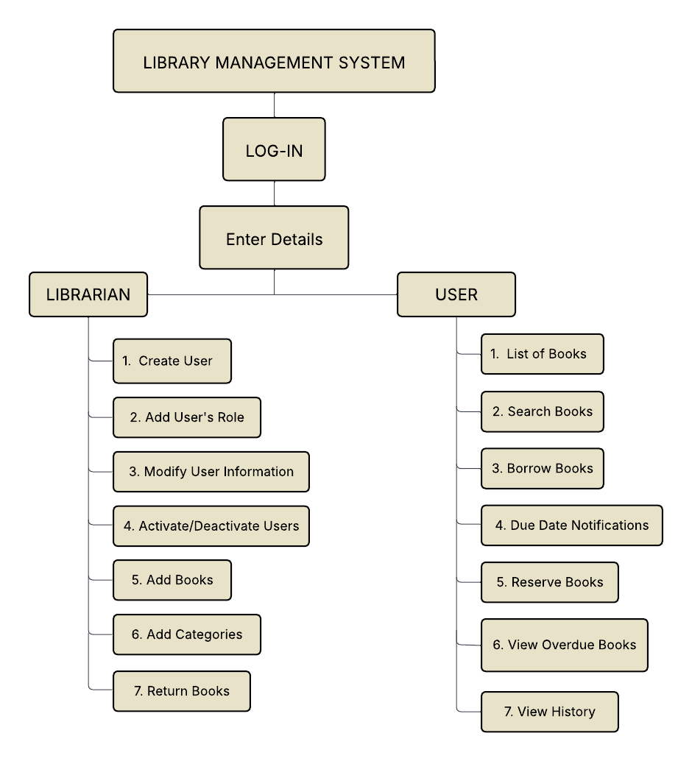**Work Breakdown Structure**

**Cost and Benefit Analysis**

Maintaining the library through manual processes at Benedicto College costs roughly **Php 579,648.00** over a span of 9 months. This includes developer salaries, web hosting, printing materials, and paper supplies. In comparison, developing the proposed automated system would require a one-time expense of around **Php 543,108.00**.

The manual system involves continuous spending, while the automated version is designed to be more cost-effective over time. It reduces the need for printing, speeds up library operations, and simplifies tasks like book tracking and sending notifications.

Although the system requires an initial investment, it brings long-term advantages—such as increased efficiency, better accuracy, and a smoother experience for both students and staff—making it a worthwhile upgrade for the college.

Below is the calculation of how much are the costs and benefits in a Library Management System.

**Table 1**

**Existing Cost**

|  |  |  |
| --- | --- | --- |
| Developer Salary (Front & Back-End) | Php 30,000 × 2 × 9 months | Php 540,000.00 |
| Web Hosting | Php 3,108/year | Php 3,108.00 |
| Printing Supplies & Electricity | Php 2,900/month × 9 months | Php 26,100.00 |
| Bond Papers for Document Printing | Php 1,160 × 9 months | Php 10,440.00 |
|  |  | **Php 579,648.00** |

**Table 2**

**Development Cost (Total Expenses)**

|  |  |
| --- | --- |
| **Position/Item** | **Monthly Cost (Php)** |
| Front-End Developer | 25,000 |
| Back-End Developer | 35,000 |
| Web Hosting (Fixed Cost) | 3,108 (1 year) |
| **Monthly Total** | Php 60,000.00 |

**Development Duration: 9 months**

**Total Development Cost**: Php 540,000 + Php 3,108 = Php 543,108.00

The total cost of Php 543,108.00 reflects the institution’s projected investment for building the Automated Library System. The table below provides a month-by-month breakdown of the development expenses across the 9-month duration.

**Figure 3**

**Monthly Expenses**

**MOSCOW**

**IMPLEMENTATION OF AUTOMATED LIBRARY MANAGEMENT SYSTEM WITH AI INTEGRATION**

Must Have

1. Log In / Authentication (Admin, Librarian, Student, Faculty)
2. Book Catalog Management (Add, Edit, Delete, Categorize Books)
3. Search and Browse Books (Title, Author, Category, ISBN)
4. Borrowing & Returning Module (Real-time updates of availability and due dates)
5. User Management (Create, update, and deactivate user accounts)
6. Notification System (Due/Overdue Alerts, Reservation Approvals/Denials)
7. AI Integration for Smart Search & Book Recommendations

**Should Have**

* Reservation System (Users can reserve books online)
* Multiple Role-Based Access (Admin, Librarian, Faculty, Student)
* Inventory Tracking (Available, lost, damaged, or archived books)
* Fine Management System (Automatic computation of overdue penalties)
* AI Chatbot for Assistance (Helps users find books faster)
* Book Archiving System (Archive outdated/damaged books but retain records for references purposes)

Could Have

* Integration with E-Library / Digital Resources (eBooks, Journals, Research Papers)
* Analytics Dashboard (Borrowing trends, peak library hours, most borrowed books)

Won’t Have

* Payment Gateway for Fines (handled manually by library staff)
* Third-party Bookstore Integration (system limited to Benedicto College library resources)

Figure 5

**Critical Path**

**Data and Process Modeling**

This capstone project applies data and process modeling to design a web-based, AI-powered library management system that streamlines cataloging, borrowing, and monitoring processes. Using Data Flow Diagrams (DFDs), the system is first represented in a high-level context diagram, showing interactions between external entities such as students, faculty, librarians, and administrators with the system’s core functions. Inputs like book details, user information, and borrowing requests flow into the system, while outputs such as availability status, borrowing records, and reports are generated. These are further broken down into detailed process levels, illustrating how tasks such as adding books, managing users, approving borrow requests, and generating reports are executed. This structured modeling ensures a clear understanding of system workflows, reduces redundancy, and serves as a practical guide for development, aligning real-world library operations with their digital implementation.

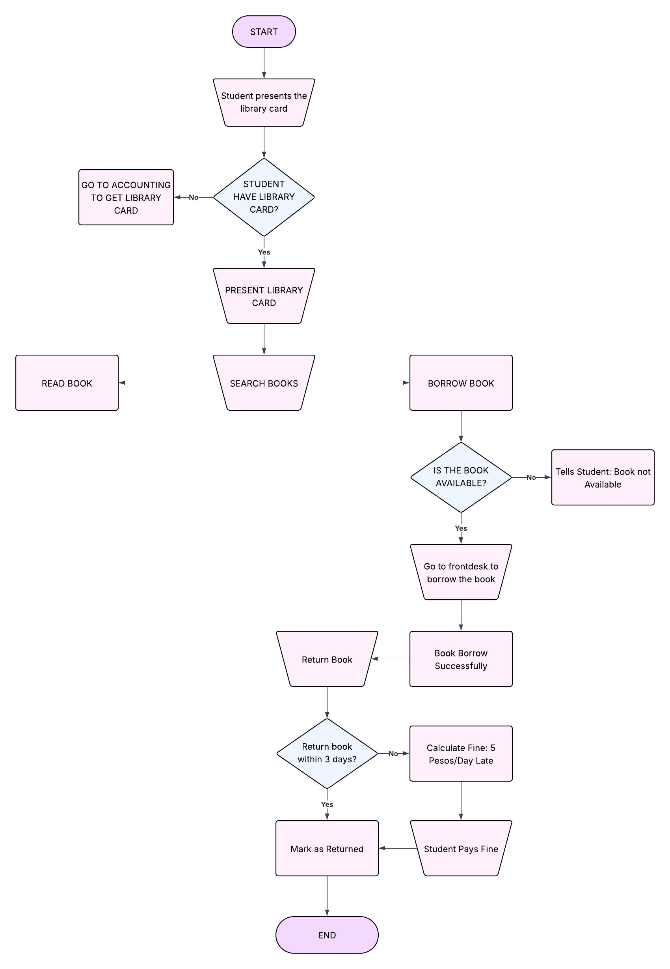

**Figure 6**

**Existing Flowchart**

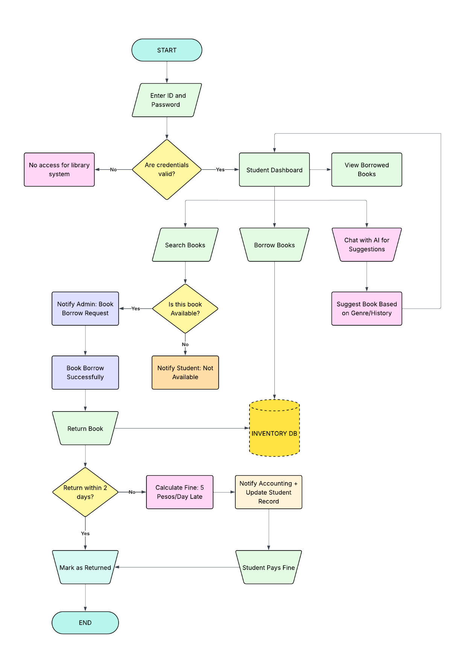

Figure 7

**Proposed Flowchart**

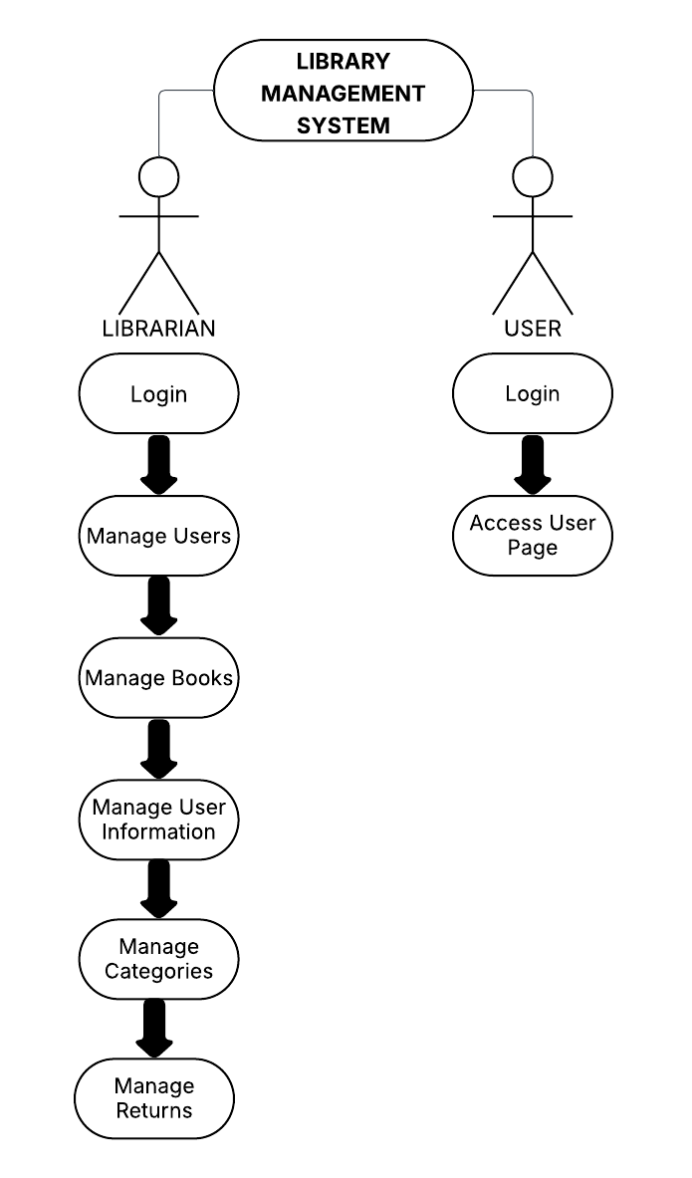

Figure 8

**Use Case Diagram**

**Narrative**

**Table 4**

**Log In**

|  |  |
| --- | --- |
| **Use Case:** | **Log In** |
| **Summary:** | **They should log in their account to access the library system portal.** |
| **Actors:** | **Super Admin, Admin, Librarian, Teachers, Students** |
| **Purpose:** | **To access the library system portal** |
| **Pre-Condition:** | **Enter credentials to log in** |
| **Post-Condition** | **Access the account** |
| **Exception:** |  |

|  |  |
| --- | --- |
| **FLOW OF EVENTS** | |
| **Actors Response** | **System Response** |
| 1. **Visit Website** | 1. **Display Website** |
| 1. **Click Login** | 1. **Display Login** |
| 1. **Enter Username and Password** | 1. **Successfully Login** |
| **ALTERNATIVE FLOW OF EVENTS** | |
| **5.1 If username/password is blank** | **5.2 Display Error** |
| **5.3 Username and Password is invalid** | **5.4 Incorrect Password or Username** |

**Table 5**

**Add Users**

|  |  |
| --- | --- |
| **Use Case:** | **Accounts** |
| **Summary:** | **Add user Accounts** |
| **Actors:** | **Super Admin** |
| **Purpose:** | **Create users’ accounts** |
| **Pre-Condition:** | **Super admins has access to the website and details of the users.** |
| **Post-Condition** | **New user added** |
| **Exception:** |  |

|  |  |
| --- | --- |
| **FLOW OF EVENTS** | |
| **Actors Response** | **System Response** |
| 1. **Visit Website** | 1. **Display Website** |
| 1. **Click Login** | 1. **Display Login** |
| 1. **Enter Username and Password** | 1. **Successfully Login** |
| **ALTERNATIVE FLOW OF EVENTS** | |
| **5.1 If username/password is blank** | **5.2 Display Error** |
| **5.3 Username and Password is invalid** | **5.4 Incorrect Password or Username** |

**Table 6**

**Add Books**

|  |  |
| --- | --- |
| **Use Case:** | **FOR BOOKS** |
| **Summary:** | **Librarian can add books.** |
| **Actors:** | **Librarian/Staff** |
| **Purpose:** | **To add new books so users can borrow/read them.** |
| **Pre-Condition:** | **Librarian/Staff must be logged into the system.** |
| **Post-Condition** | **The book is visible in the lists and searchable by users.** |
| **Exception:** | **Missing details, duplicate entry, or system error.** |

|  |  |
| --- | --- |
| **FLOW OF EVENTS** | |
| **Actors Response** | **System Response** |
| 1. **Visit Website** | 1. **Display Website** |
| 1. **Click Login** | 1. **Display Login** |
| 1. **Enter Username and Password** | 1. **Successfully Login** |
| **ALTERNATIVE FLOW OF EVENTS** | |
| **5.1 If username/password is blank** | **5.2 Display Error** |
| **5.3 Username and Password is invalid** | **5.4 Incorrect Password or Username** |

Figure 9

**Activity Diagram**

Figure 10

**State Chart Diagram**

**Design**

Figure 25

**Entity Relationship Diagram**

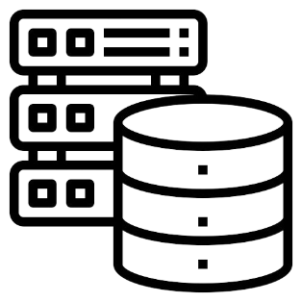

**ADMINISTRATOR**

**ADMIN VISUAL**

**INTERFACE**

**TEACHER**

**USER**

**INTERFACE**

**WEB SERVER**

**DATABASE**

**Figure 26**

**System Architecture**

**Security**

**Development**